Gmdistribution.fit : Gaussian mixture parameter estimates
obj = gmdistribution.fit(X,k) uses an Expectation Maximization (EM) algorithm to construct an object obj of the gmdistribution class containing maximum likelihood estimates of the parameters in a Gaussian mixture model with k components for data in the n-by-d matrix X, where n is the number of observations and d is the dimension of the data.
AIC = Akaike Information Criterion = measure of ‘goodness of fit’. Lower AIC = better goodness of fit

figure;
for index = 1:8
subplot(4,2,index);

% draw samples from standard normal distribution
x = [randn(1000,1); index-1+randn(1000,1)];

[n binCenters] = hist(x);
h = bar(binCenters, n);

title(['Plot ' num2str(index)]);
disp(['Plot ' num2str(index)]);

f1 = gmdistribution.fit(x,1); % single component, unimodal
disp(['Single component AIC: ' num2str(f1.AIC)]);
f2 = gmdistribution.fit(x,2); % two components, bimodal
disp(['Double component AIC: ' num2str(f2.AIC)]);

if(f2.AIC<f1.AIC)
disp('Bimodal: YES');
else
disp('Bimodal: NO');
end

ksResult = kstest(x);
if(ksResult == 1)
disp('One sample Kolmogorov-Smirnoff test (.05): non-normal distribution');
else
disp('One sample Kolmogorov-Smirnoff test (.05): normal distribution');
end
end

% draw samples from standard normal distribution
x = [randn(1000,1); index-1+randn(1000,1)];

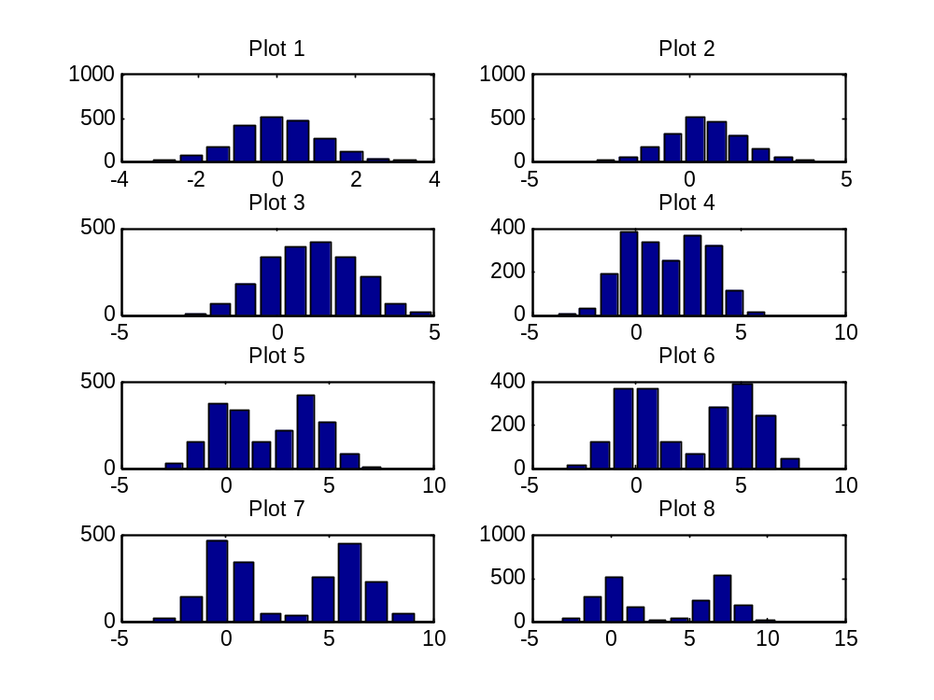
Script output:
Plot 1
Single component AIC: 5687.5897
Double component AIC: 5692.6721
Bimodal: NO
One sample Kolmogorov-Smirnoff test (.05): normal distribution
Plot 2
Single component AIC: 6124.5094
Double component AIC: 6129.5215
Bimodal: NO
One sample Kolmogorov-Smirnoff test (.05): non-normal distribution
Plot 3
Single component AIC: 6927.6162
Double component AIC: 6901.5477
Bimodal: YES
One sample Kolmogorov-Smirnoff test (.05): non-normal distribution
Plot 4
Single component AIC: 8088.5238
Double component AIC: 8094.5115
Bimodal: NO
One sample Kolmogorov-Smirnoff test (.05): non-normal distribution
Plot 5
Single component AIC: 8892.6904
Double component AIC: 8898.638
Bimodal: NO
One sample Kolmogorov-Smirnoff test (.05): non-normal distribution
Plot 6
Single component AIC: 9669.9928
Double component AIC: 8461.1922
Bimodal: YES
One sample Kolmogorov-Smirnoff test (.05): non-normal distribution
Plot 7
Single component AIC: 10302.9984
Double component AIC: 10308.9061
Bimodal: NO
One sample Kolmogorov-Smirnoff test (.05): non-normal distribution
Plot 8
Single component AIC: 10838.4476
Double component AIC: 10844.2889
Bimodal: NO
One sample Kolmogorov-Smirnoff test (.05): non-normal distribution

% draw samples from standard normal distribution
x = [randn(1000,1); index-1+randn(500,1)];

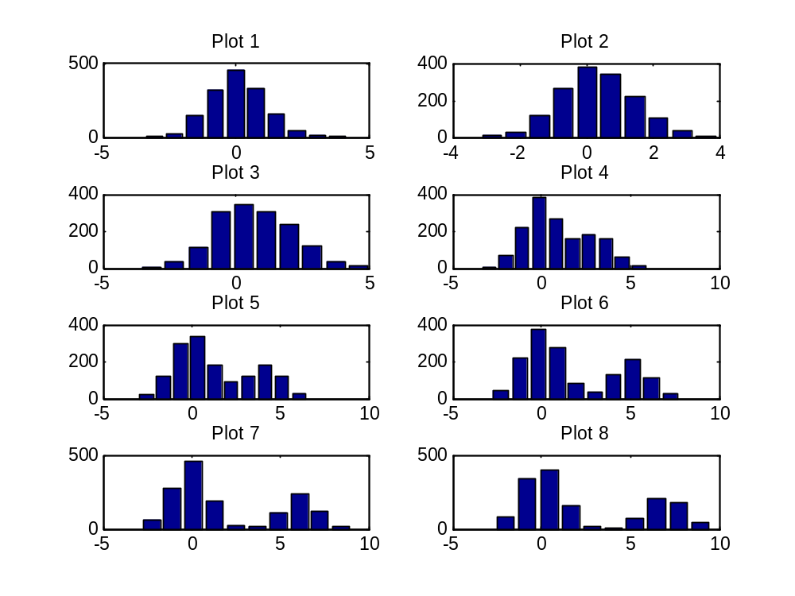
Plot 1
Single component AIC: 4306.758
Double component AIC: 4312.1424
Bimodal: NO
One sample Kolmogorov-Smirnoff test (.05): normal distribution
Plot 2
Single component AIC: 4518.8035
Double component AIC: 4521.6582
Bimodal: NO
One sample Kolmogorov-Smirnoff test (.05): non-normal distribution
Plot 3
Single component AIC: 5231.2633
Double component AIC: 5213.4007
Bimodal: YES
One sample Kolmogorov-Smirnoff test (.05): non-normal distribution
Plot 4
Single component AIC: 5924.9837
Double component AIC: 5704.7637
Bimodal: YES
One sample Kolmogorov-Smirnoff test (.05): non-normal distribution
Plot 5
Single component AIC: 6573.1898
Double component AIC: 6038.2889
Bimodal: YES
One sample Kolmogorov-Smirnoff test (.05): non-normal distribution
Plot 6
Single component AIC: 7123.1643
Double component AIC: 6165.6584
Bimodal: YES
One sample Kolmogorov-Smirnoff test (.05): non-normal distribution
Plot 7
Single component AIC: 7609.5546
Double component AIC: 6075.3984
Bimodal: YES
One sample Kolmogorov-Smirnoff test (.05): non-normal distribution
Plot 8
Single component AIC: 7947.701
Double component AIC: 6182.7376
Bimodal: YES
One sample Kolmogorov-Smirnoff test (.05): non-normal distribution

